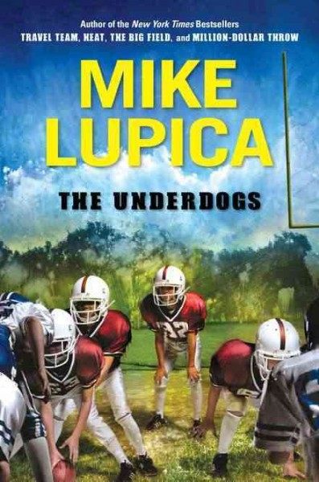
Dear Parents
Best Selling Author of the Mike Lupica will be visiting our school on Monday, September 26st. Mr. Lupica will be sharing his experiences and reading from his new book “The Underdogs”. You may pre-order autographed copies of this book through the School. The book will be delivered to your child’s classroom after the presentation. If you would like to place a pre-order, please fill out the form below and return it to your child’s teacher along with payment no later than Friday September 23rd 2011

__ New -The Underdogs- Hard Cover- ____ price includes tax

___ Heat $ ________paper back- price includes tax
___ Hero $________ paperback price includes tax
___ Batboy $________ paperback price includes tax
___ Travel Team $________ paperback price includes tax
___ Million Dollar Throw $________ paperback price includes tax
___ $________ paperback price includes tax

Total books ordered________________ Total cost__________________
PLEASE PRINT CLEARLY & MAKE ALL CHECKS PAYABLE TO__________________
Student Name ________________________________ Teacher ______________________
Phone Number ______________________ Total amount paid_______________________
Friday September 23rd is the last day to pre-order books

Thank you Books & Books for bringing this event to our school!

